1-Web Front-End

Definition
# Source: AI Source: Provided by: [Data Path: Persons Table -> ID Column: 1, Name_En Column: Motasem Essam] -> From: [Chatgpt (GPT‑5 Mini)] on [2/12/2026]
The Web Front-End is the part of a website or web application that users see and interact with directly in their web browser. It’s also called the client-side because it runs on the user’s device rather than the server.

Simple Definition
# Source: AI Source: Provided by: [Data Path: Persons Table -> ID Column: 1, Name_En Column: Motasem Essam] -> From: [Chatgpt (GPT‑5 Mini)] on [2/12/2026]
Web Front-End = everything users see and interact with on a website, including layout, design, content, and interactive elements.

Key Components of Web Front-End
# Source: AI Source: Provided by: [Data Path: Persons Table -> ID Column: 1, Name_En Column: Motasem Essam] -> From: [Chatgpt (GPT‑5 Mini)] on [2/12/2026]
- HTML (HyperText Markup Language)
  - Structure and content of web pages
  - Example: headings, paragraphs, images, links
- CSS (Cascading Style Sheets)
  - Styles the website: colors, fonts, spacing, layout
  - Example: making a button red or a page responsive
- JavaScript (JS)
  - Adds interactivity and dynamic behavior
  - Example: image sliders, pop-ups, form validation
- TypeScript (TS)
  - A superset of JavaScript that adds static typing
  - Helps catch errors during development and makes code easier to maintain
  - Often used with frameworks like React, Angular, and Vue
- Front-End Frameworks / Libraries
  - Pre-built tools to speed development and manage complexity
  - Examples: React, Angular, Vue
- UI / UX Design
  - Layout, typography, and navigation that make websites user-friendly
- Responsive Design
  - Ensures the site works well on desktop, tablet, and mobile

Purpose of Web Front-End
# Source: AI Source: Provided by: [Data Path: Persons Table -> ID Column: 1, Name_En Column: Motasem Essam] -> From: [Chatgpt (GPT‑5 Mini)] on [2/12/2026]
- Deliver visual interface and interaction for users
- Make websites engaging, usable, and accessible
- Connect to the back-end to display dynamic data
- Ensure websites are responsive and fast

Examples
# Source: AI Source: Provided by: [Data Path: Persons Table -> ID Column: 1, Name_En Column: Motasem Essam] -> From: [Chatgpt (GPT‑5 Mini)] on [2/12/2026]
- E-commerce product pages with images, buttons, and shopping cart
- Blogs with article layout, images, and “Read More” buttons
- Dashboards with charts, tables, and filters
- Landing pages with animations and call-to-action buttons

Front-end Roadmap Image
# Source: ScreenShots Source: Provided by: [Persons Table -> ID Column: 1, Name_En Column: Motasem Essam] -> Tool: [Lightshot Program] -> From [Table Source: Data Path: Miscellaneous Folder -> Miscellaneous Database -> Miscellaneous Topics Table -> ID: 36] on [2/12/2026]
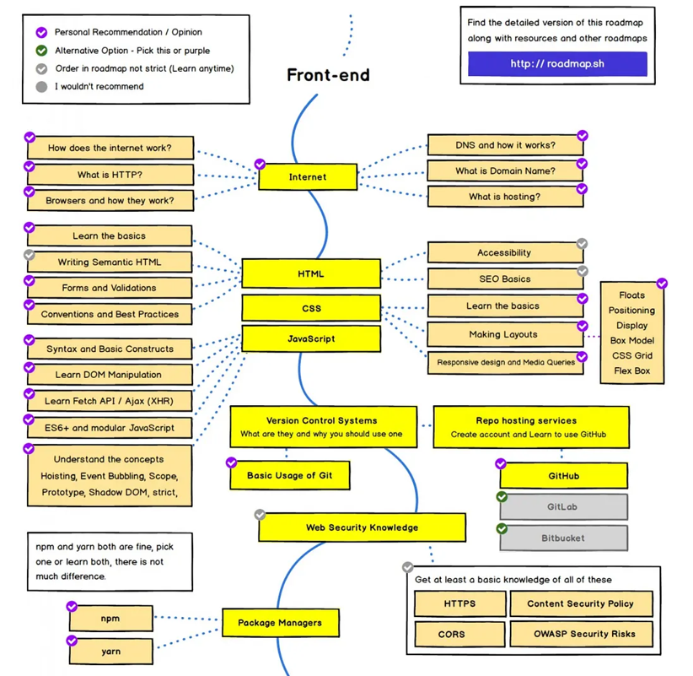
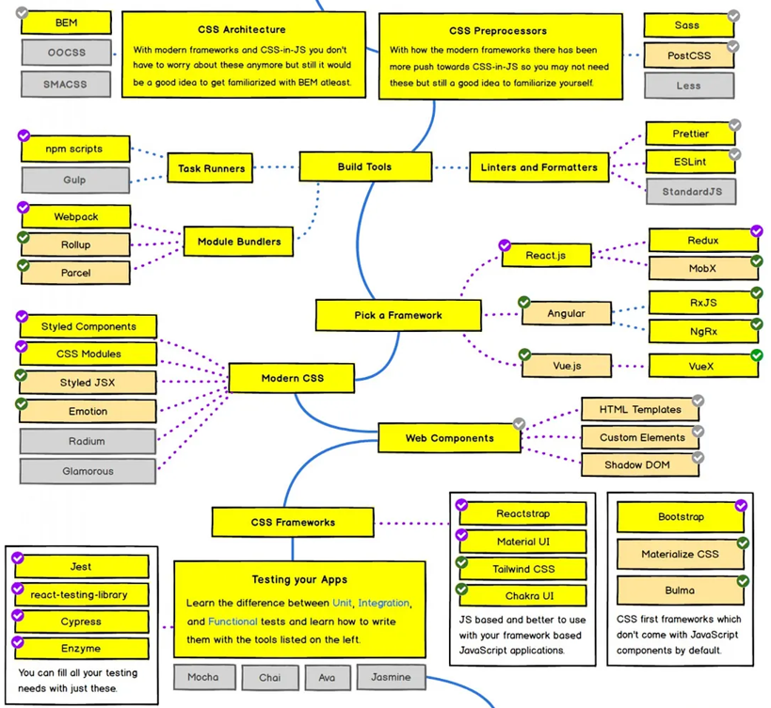
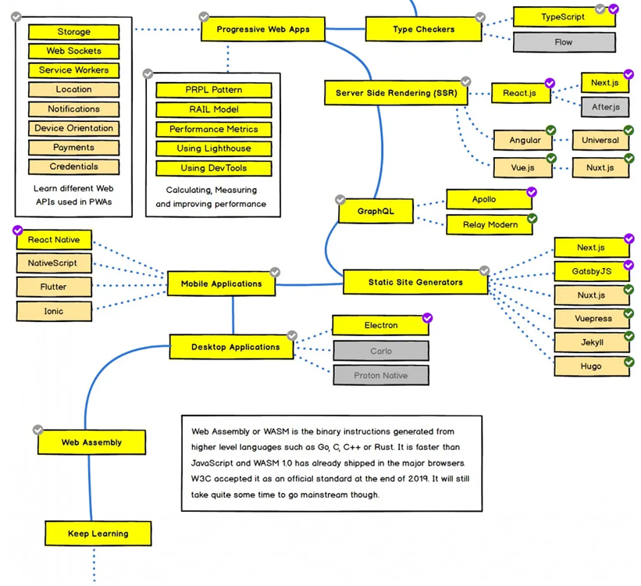

Difference Between Front-End and Back-End (Web)
# Source: AI Source: Provided by: [Data Path: Persons Table -> ID Column: 1, Name_En Column: Motasem Essam] -> From: [Chatgpt (GPT‑5 Mini)] on [2/12/2026]
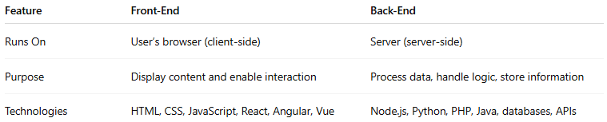
Feature | Front-End | Back-End
Runs On | User’s browser (client-side) | Server (server-side)
Purpose | Display content and enable interaction | Process data, handle logic, store information
Technologies | HTML, CSS, JavaScript, React, Angular, Vue | Node.js, Python, PHP, Java, databases, APIs

2-Web Back-End

Definition
# Source: AI Source: Provided by: [Data Path: Persons Table -> ID Column: 1, Name_En Column: Motasem Essam] -> From: [Chatgpt (GPT‑5 Mini)] on [2/12/2026]
The Web Back-End is the server-side part of a website or web application that users don’t see directly. It’s responsible for processing data, managing databases, running application logic, and communicating with the front-end.

Simple Definition
# Source: AI Source: Provided by: [Data Path: Persons Table -> ID Column: 1, Name_En Column: Motasem Essam] -> From: [Chatgpt (GPT‑5 Mini)] on [2/12/2026]
Web Back-End = the part of a website or web app that handles data, logic, and server operations behind the scenes.

Key Components of Web Back-End
# Source: AI Source: Provided by: [Data Path: Persons Table -> ID Column: 1, Name_En Column: Motasem Essam] -> From: [Chatgpt (GPT‑5 Mini)] on [2/12/2026]
- Server / Server-Side Languages
  - Handles requests from the front-end and returns responses
  - Examples: Node.js (JavaScript/TypeScript), Python, Java, PHP, C#, Ruby
- Databases
  - Stores, retrieves, and manages data
  - Examples: MySQL, PostgreSQL, MongoDB, SQLite, Redis
- APIs / Web Services
  - Interfaces for communication between front-end and back-end
  - Examples: RESTful APIs, GraphQL, WebSocket
- Server Frameworks
  - Tools and frameworks to speed up development
  - Examples: Express.js (Node.js), Django (Python), Spring Boot (Java), Laravel (PHP)
- Authentication & Security
  - Ensures data is secure and users are properly authenticated
  - Examples: OAuth, JWT, SSL/TLS, password hashing
- Business Logic / Application Logic
  - Implements the rules, calculations, and workflows of the application
  - Example: shopping cart calculations, user permissions, order processing
- Version Control & Deployment
  - Tools to manage code changes and deploy applications
  - Examples: Git, Docker, CI/CD pipelines, cloud platforms (AWS, Azure, GCP)

Purpose of Web Back-End
# Source: AI Source: Provided by: [Data Path: Persons Table -> ID Column: 1, Name_En Column: Motasem Essam] -> From: [Chatgpt (GPT‑5 Mini)] on [2/12/2026]
- Process and respond to front-end requests
- Manage databases and data storage
- Enforce business rules and logic
- Ensure security, scalability, and performance

Back-end Roadmap Image
# Source: ScreenShots Source: Provided by: [Persons Table -> ID Column: 1, Name_En Column: Motasem Essam] -> Tool: [Lightshot Program] -> From [Table Source: Data Path: Miscellaneous Folder -> Miscellaneous Database -> Miscellaneous Topics Table -> ID: 37] on [2/12/2026]
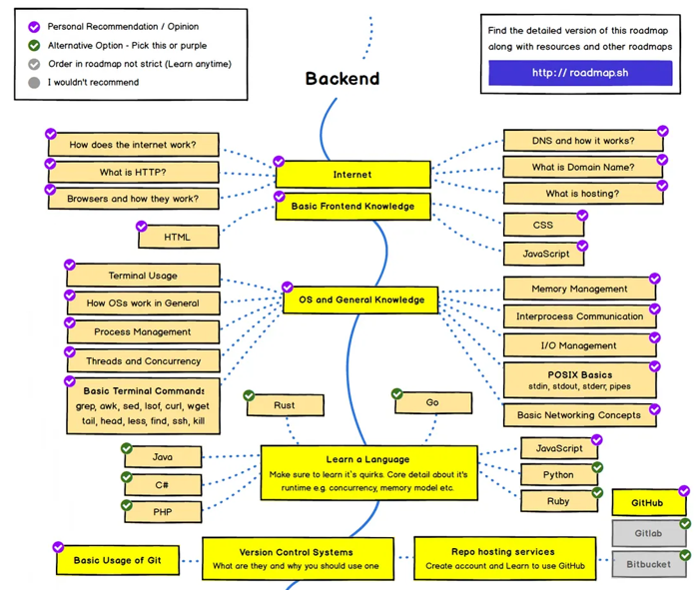
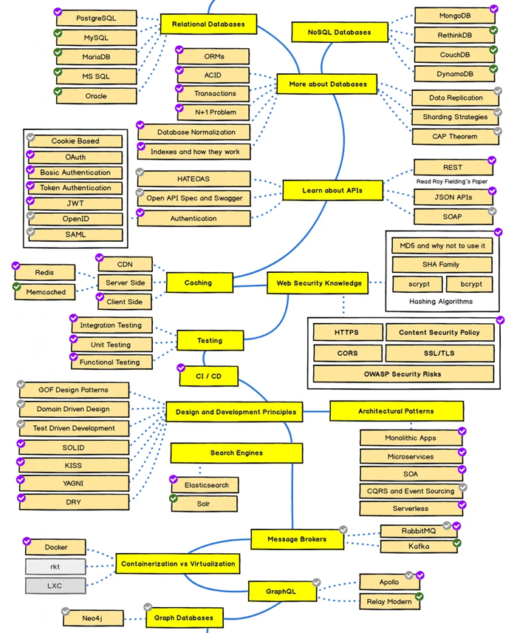
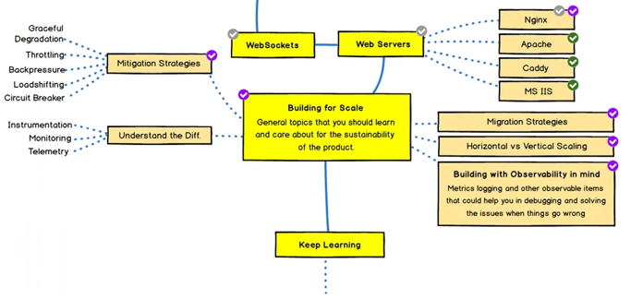

Examples
# Source: AI Source: Provided by: [Data Path: Persons Table -> ID Column: 1, Name_En Column: Motasem Essam] -> From: [Chatgpt (GPT‑5 Mini)] on [2/12/2026]
- E-commerce → processing orders, managing inventory, handling payments
- Social media → storing posts, comments, and user profiles
- Dashboards → fetching data from servers to display charts and statistics
- IoT web interfaces → receiving sensor data and sending commands to devices

Difference Between Web Front-End and Back-End
# Source: AI Source: Provided by: [Data Path: Persons Table -> ID Column: 1, Name_En Column: Motasem Essam] -> From: [Chatgpt (GPT‑5 Mini)] on [2/12/2026]
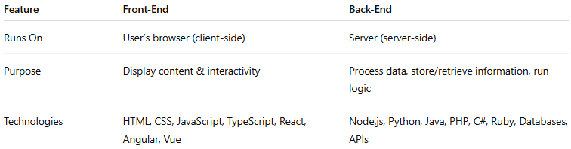
Feature | Front-End | Back-End
Runs On | User’s browser (client-side) | Server (server-side)
Purpose | Display content & interactivity | Process data, store/retrieve information, run logic
Technologies | HTML, CSS, JavaScript, TypeScript, React, Angular, Vue | Node.js, Python, Java, PHP, C#, Ruby, Databases, APIs

3-Web Full-Stack

Definition
# Source: AI Source: Provided by: [Data Path: Persons Table -> ID Column: 1, Name_En Column: Motasem Essam] -> From: [Chatgpt (GPT‑5 Mini)] on [2/12/2026]
Web Full-Stack refers to the combination of both the front-end and back-end of a web application. A full-stack developer can handle everything from designing the user interface to managing databases and server-side logic, making a complete web application.

Simple Definition
# Source: AI Source: Provided by: [Data Path: Persons Table -> ID Column: 1, Name_En Column: Motasem Essam] -> From: [Chatgpt (GPT‑5 Mini)] on [2/12/2026]
Web Full-Stack = the complete set of technologies and skills needed to build both the client-side (front-end) and server-side (back-end) of a web application.

Key Components of Web Full-Stack
# Source: AI Source: Provided by: [Data Path: Persons Table -> ID Column: 1, Name_En Column: Motasem Essam] -> From: [Chatgpt (GPT‑5 Mini)] on [2/12/2026]
1. Front-End (Client-Side)
- Languages: HTML, CSS, JavaScript, TypeScript
- Frameworks / Libraries: React, Angular, Vue
- UI / UX Design Tools: Figma, Adobe XD, Photoshop
- Responsive Design: Works on desktop, tablet, and mobile
- Interactivity: Sliders, forms, buttons, modals, animations
2. Back-End (Server-Side)
- Languages / Platforms: Node.js (JavaScript/TypeScript), Python, Java, PHP, C#, Ruby
- Frameworks: Express.js, Django, Spring Boot, Laravel
- Databases: MySQL, PostgreSQL, MongoDB, SQLite, Redis
- APIs / Web Services: REST, GraphQL, WebSocket
- Authentication & Security: OAuth, JWT, SSL/TLS
- Business Logic: Processing orders, handling data, server rules
3. Deployment / DevOps
- Version Control: Git, GitHub, GitLab
- Containers & CI/CD: Docker, Kubernetes, CI/CD pipelines
- Cloud Platforms: AWS, Azure, GCP

Purpose of Web Full-Stack
# Source: AI Source: Provided by: [Data Path: Persons Table -> ID Column: 1, Name_En Column: Motasem Essam] -> From: [Chatgpt (GPT‑5 Mini)] on [2/12/2026]
- Build complete web applications from UI to server and database
- Ensure smooth interaction between front-end and back-end
- Handle deployment, maintenance, and scalability
- Provide end-to-end solutions for web projects

Examples
# Source: AI Source: Provided by: [Data Path: Persons Table -> ID Column: 1, Name_En Column: Motasem Essam] -> From: [Chatgpt (GPT‑5 Mini)] on [2/12/2026]
- E-commerce platform → product pages, shopping cart, payment system, admin dashboard
- Social media platform → posts, comments, user authentication, notifications
- Blogging platform → article creation, storage, display, and search functionality
- Web dashboards → user-friendly interface + back-end data processing

Difference Between Web Full-Stack, Front-End, and Back-End
# Source: AI Source: Provided by: [Data Path: Persons Table -> ID Column: 1, Name_En Column: Motasem Essam] -> From: [Chatgpt (GPT‑5 Mini)] on [2/12/2026]
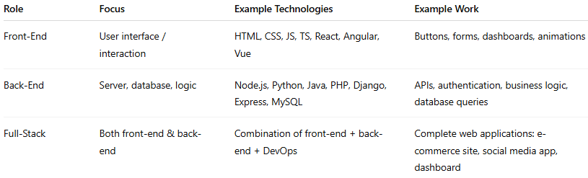
Role | Focus | Example Technologies | Example Work
Front-End | User interface / interaction | HTML, CSS, JS, TS, React, Angular, Vue | Buttons, forms, dashboards, animations
Back-End | Server, database, logic | Node.js, Python, Java, PHP, Django, Express, MySQL | APIs, authentication, business logic, database queries
Full-Stack | Both front-end & back-end | Combination of front-end + back-end + DevOps | Complete web applications: e-commerce site, social media app, dashboard

